The title of this paper in English (Arial 11pt)

論文のタイトル(The title in Japanese, MS Gothic 11pt)

\*if you do not use Japanese, the editorial team will do

Firstname Familyname (Affiliation) \*1 and Firstname Fmilyname (Affiliation) \*2 (Arial 10.5pt)

\*1 xxxxxx@xxx.com (e-mail address/mailing address of corresponding author)

\*2 xxxxxx@xxx.com (e-mail address/mailing address for other corresponding author(s)if exist)

If more corresponding authors, please add as \*2, \*3, \*4…with e-mail address or mailing address

\*, number and address are by Times New Roman 10pt

English Abstract: (Arial 10.5pt)

Less than 200 words. Please write in English. This is a sample summary. (Times New Roman 10.5pt)

Keywords: (Arial 10.5pt) Keyword, Keyword, Keyword, Keyword, Keyword (5 words in maximum, Times New Roman 10.5pt)

和文要旨 (Japanese Abstract):

　300字以内。10ポイントの明朝体フォントを用いて下さい。Please write your abstract in Japanese if possible (300 letters in maximum, MS Mincho 10pt). Otherwise, the editorial team will translate your English abstract into Japanese.

キーワード (Japanese keywords): (MSゴシック10.5pt) 〇〇〇、〇〇〇、〇〇〇、〇〇〇、〇〇〇　（MS明朝10pt）

1. Introduction (Arial 10.5pt)

Please write main texts in 10pt of Times New Roman. All letters should be half-width except for East Asian letters such as Japanese, Korean and Chinese letters. This template is just a sample. Here is a citation example of sole works: (Family 2020: 20). Here is a citation example of collaborated works (2 authors): (Family and Family 2020: 20-21). Here is a citation example of collaborated works: (3 authors and more): (Family et al. 2020: 20-21).

2. Previous studies (Arial 10.5pt)

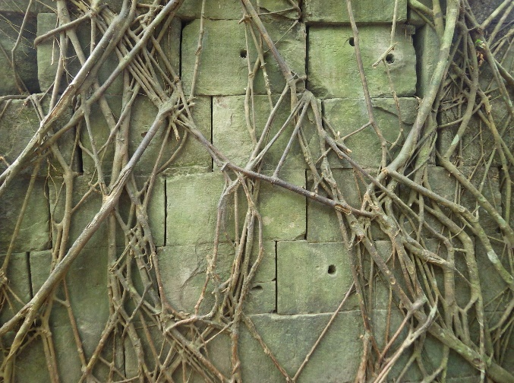Please write main texts in 10pt of Times New Roman. All letters should be half-width except for East Asian letters such as Japanese, Korean and Chinese letters. This template is just a sample \*1.

3. Analysis (Arial 10.5pt)

3-1. Objects and method (Arial 10.5pt)

Please write main texts in 10pt of Times New Roman. All letters should be half-width except for East Asian letters such as Japanese, Korean and Chinese letters. This template is just a sample.

3-2. Results of analysis (Arial 10.5pt)

Please write main texts in 10pt of Times New Roman. All letters should be half-width except for East Asian letters such as Japanese, Korean and Chinese letters. This template is just a sample.

Fig. 1. For captions of maps and photos, please use “Fig.” (source of figure)

4. Discussion (Arial 10.5pt)

Table 1. Sample Table (source of table)



Please write main texts in 10pt of Times New Roman. All letters should be half-width except for East Asian letters such as Japanese, Korean and Chinese letters. This template is just a sample.

5. Conclusion (Arial 10.5pt)

Please write main texts in 10pt of Times New Roman. All letters should be half-width except for East Asian letters such as Japanese, Korean and Chinese letters. This template is just a sample.

Acknowledgement: (Arial 10.5pt)

I really appreciate Prof. X, Dr. X and Dr. X. This work was supported by XXX Fund (no. xxxx). (Times New Roman 10pt)

Notes: (Arial 10.5pt)

1: Lorem ipsum dolor sit amet, consectetuer adipiscing elit. Maecenas porttitor congue massa. (Times New Roman 10pt)

2: Fusce posuere, magna sed pulvinar ultricies, purus lectus malesuada libero, sit amet commodo magna eros quis urna. Nunc viverra imperdiet enim.

References: (Arial 10.5pt)

(English and other languages) Please list in ABC order.

Family, F. (2020). *The title of a book*. Publisher: London. (Times New Roman 9pt)

Family, F., F. Family and F. Family (2020). The title of a paper. *The title of a journal*, 20(2): 20-34.

Family, F. (2020). The title of a paper. In First Family and First Family (eds.) *The title of a festschrift*, 20-34. Publisher: London.

Family, F. (2020). Chapter 2: The title of a chapter. In First Family and First Family (eds.) *The archaeology of X*, 20-34. Publisher: London.

Myouji N. (2020). *The archaeology of Japan* (Nihon no koukogaku). Publisher: Tokyo. In Japanese

Hộ T. (2020). The title of a paper (Original title in alphabet). *The title of a journal* (Original title in alphabet). Publisher: Hà Nội. In Vietnamese.